PERSONAL EXPENSE TRACKER APPLICATION

Course Project Phase 2 — Final Submission Report

1. COVER PAGE
PROJECT TITLE: Personal Expense Tracker Application
PROJECT PHASE: Phase 2 – Final Project Submission
SUBMITTED BY: Alina Farooq
ROLL NUMBER: L1F23BSSE0361
SUBMITTED TO: Sir Abdul Rehman Hashmi
DATE: June 17, 2026

2. INTRODUCTION
The Personal Expense Tracker is a desktop-based software solution developed in Java using the Swing framework for its graphical user interface. The application provides users with an efficient platform to record, monitor, and manage their personal financial transactions by tracking both income and expenses.
The system maintains transaction records using text-file storage, eliminating the need for external database management systems. Through an intuitive graphical interface, users can easily organize financial activities, calculate balances, and search transaction history, making personal finance management more convenient and reliable.

3. OBJECTIVES
The major objectives of this project are:
- To design a user-friendly and modern graphical user interface using Java Swing.
- To implement Object-Oriented Programming (OOP) concepts including Inheritance, Polymorphism, Abstraction, and Encapsulation.
- To provide reliable data persistence through text-file handling without requiring a database server.
- To implement comprehensive input validation and exception handling mechanisms.
- To develop a secure login system for controlled access to application features.
- To provide transaction search and filtering functionality for quick record retrieval.

4. PROBLEM STATEMENT
Managing personal finances manually can be difficult and error-prone. Traditional methods such as handwritten ledgers or basic note-taking applications often lack automation, proper organization, and financial summaries.
Users frequently encounter difficulties when tracking expenses, analyzing spending habits, or calculating available balances. The absence of structured financial records may result in poor budgeting decisions and inaccurate financial monitoring.
The Personal Expense Tracker addresses these issues by providing a standalone desktop application that automates transaction management, performs balance calculations, stores records securely, and offers search functionality for efficient financial tracking.

5. APPLICATION SCREENSHOTS
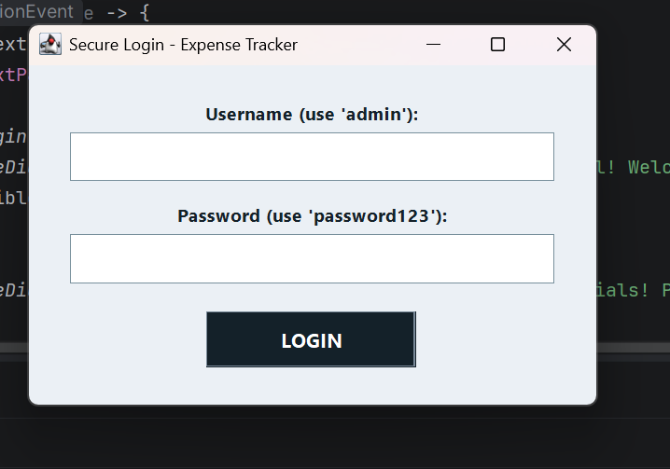
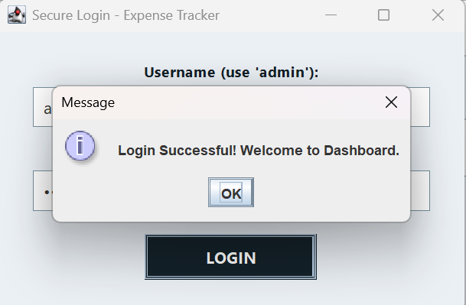
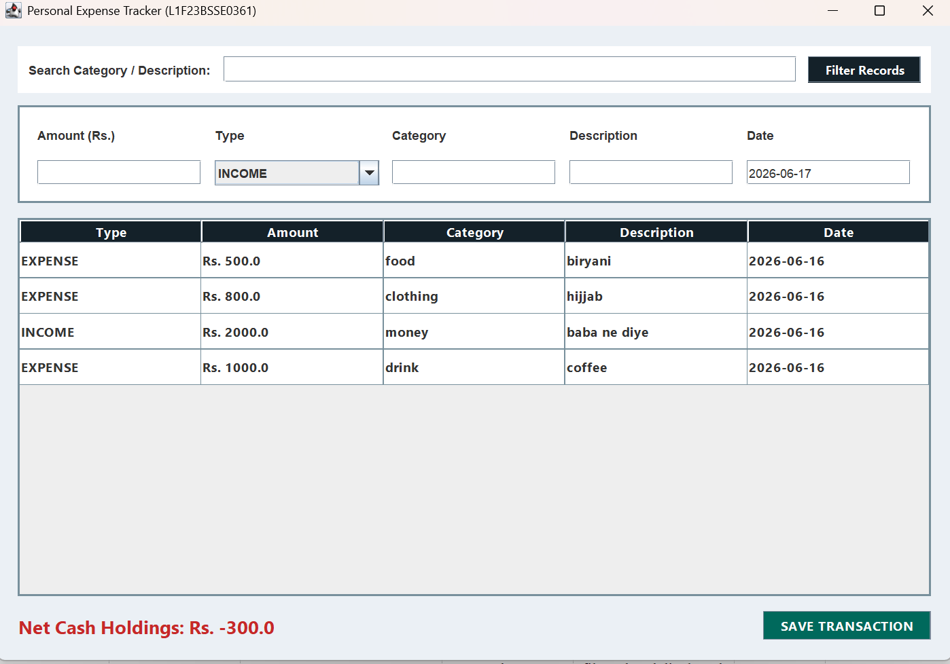

6. QUALITY ASSURANCE AND SYSTEM TESTING
The application was tested using black-box testing techniques to verify that all functional requirements operate correctly and consistently.
Test Case ID | Component / Feature | Test Input | Expected Result | Status
TC-01 | Login Authentication | Username: admin Password: password123 | Successful login and dashboard access | PASSED
TC-02 | Invalid Login Check | Username: unknown Password: null | Error message displayed and access denied | PASSED
TC-03 | Input Validation | Blank transaction fields | Validation warning displayed | PASSED
TC-04 | Amount Validation | Amount = -1500.50 | Error generated for invalid amount | PASSED
TC-05 | Search Functionality | Search Keyword = “Food” | Relevant records filtered and displayed | PASSED

7. CONCLUSION
The Personal Expense Tracker application has been successfully developed and tested according to the Phase 2 project requirements. The system demonstrates the practical implementation of Java Swing, file handling, exception management, and Object-Oriented Programming principles.
By utilizing text-file storage through BufferedReader and BufferedWriter, the application provides a lightweight yet effective solution for personal financial management without requiring database integration. The modular architecture ensures maintainability, scalability, and ease of future enhancement.

8. FUTURE ENHANCEMENTS
The following improvements can be implemented in future versions of the application:

1. Graphical Reporting System
Integration of charting libraries such as JFreeChart to visualize income and expense distributions using pie charts and bar graphs.

2. Multi-User Support
Implementation of separate user accounts with dedicated transaction files and personalized financial records.

3. Budget Monitoring System
Addition of spending limits and automated notifications when users exceed predefined budget thresholds.

4. Data Export Features
Support for exporting financial reports to PDF, Excel, or CSV formats.

5. Enhanced Security
Implementation of encrypted credential storage and password recovery mechanisms.

